

Spencer Booth-Jeffs, Mason Watson, Joshua Driver, Lachlan Reid

SmiJle Team

Project Handbook

FDLMARKS 131

# Revision

Table – Version Revisions

|  |  |  |  |
| --- | --- | --- | --- |
| Version Number | Date approved | Approved by | Description |
| 1.0 | 18 – 03 - 2020 | Spencer  Jeffs | Preface, Description Non-functional requirements |
| 1.1 | 20– 03 – 2020 | Spencer Jeffs | Project Overview, Preface, Descriptions and acronyms |
| 1.2 | 23 – 03 – 2020 | Spencer Jeffs | Non-functional Requirements, 2.0 Sections |
| 1.3 | 2 – 04 – 2020 | Spencer Jeffs | Project Responsibility, Tools |
| 1.4 | 29 – 04 – 2020 | Spencer Jeffs | Constraints, Software and Systems Architecture 3.0 Sections |
| 1.5 | 30 – 04 – 2020 | Spencer Jeffs | Deliverables, Boundaries and Interfaces, Non-Functional Requirements, High level architecture, 4.0 Sections. |
| 1.6 | 3 – 05 – 2020 | Spencer Jeffs | Logo |
| 2.0 | 4 – 05 – 2020 | Spencer Jeffs | Project Deliverables, |
| 2.1 | 8 – 05 – 2020 | Spencer Jeffs | Meetings |
| 2.2 | 9 – 05 – 2020 | Spencer Jeffs | Non-Functional Requirements, Project deliverables, mostly just polishing the formats and adding updates to project |

# Preface

The purpose of this document is to provide a clear direction of the project, it will help us keep track of what kind of tests we have done previously to prevent any kinds of tests to be repeated again, thus, less loss of time, it is also a tool used to help share ideas with other team mates, to improve better efficiency, it helps provide a clear understanding of what kind of resources/ materials you might currently have.

The target audience of this document are the all of the relevant stakeholders for this project, this includes the team actively working on the project, the client, and the university staff in charge of ITECH3208. This document aims to provide all of these stakeholders the ability to understand what this project entails.

Table of Contents

Revision 1

Preface 1

List of Figures 3

List of Tables 3

Vision Statement 4

Team meetings 5

1. Introduction 6

1.1 Project Overview 6

1.2 Project Deliverables 6

1.3 Evolution of the Handbook 7

1.4 Reference Materials 8

1.5 Definitions and Acronyms 8

2. Organization 9

2.1 Process Model 9

2.2 Organizational Structure 11

2.3 Organization Boundaries and Interfaces 12

2.4 Project Responsibilities 13

3. Managerial Process 14

3.1 Management Objectives and Priorities 14

3.2 Assumptions, Dependencies, and Constraints 14

4. Technical Process 15

4.1 Methods, Tools, and Techniques 15

4.2 Software Documentation 16

5. High level Project Plan 16

6. Non-functional Requirements 18

6.1 Platform 18

6.2 Communication 18

6.3 Performance 19

6.4 Security and Privacy 19

6.5 Audience, Usability and Accessibility 19

6.6 Reliability 19

6.9 Legal 19

6.10 Standards 19

6.11 Documentation 19

7. Software and Systems Architecture 20

7.1 Architecture objectives 20

7.2 High-level architecture 20

7.3 System context 21

7.4 User Interface / Interaction Design 21

7.5 Data model and software design 22

7.6 Assumptions 22

7.7 External Dependencies 22

Additional Components 23

Index 23

Appendices 23

# List of figures

2.2 Figure 1 – Organisation chart 11

5.0 Figure 2 – Sprint Plan 16

7.1 Figure 3 – Architecture Design 19

7.2 Figure 4 - Architecture Overview 20

7.3 Figure 5 - System Context 21

7.4 Figure 6 - User Interface Design 22

7.4 Figure 7 - Sitemap 23

7.4 Figure 8 - Design Mock-up 23

7.5 Figure 9 - Database Design 24

# List of Tables

Table 1 – Version Revisions 1

1.5 Table 2 - Definitions and Acronyms 7

2.1 Table 3 - Process Model 8

# Vision Statement

1. **Problem Description**

The goal of this project is to help create a new look and functionality for the existing fdlMarks site on mobile devices, as well as refactor the existing underlying codebase for fdlMarks to help it run smoother as well as create documentation for it so that it is more easily maintainable in the future.

1. **System Capabilities**

It is critical that upon completion of the project that students are able to login into fdlMarks on their mobile device through there browser of choice and be shown their accurate grades and all of the other relevant information stored in fdlMarks about them in a more comfortable fashion than what is currently possible. It is also critical that upon the refactor of the code that underlying system for fdlMarks functions exactly the same as previously, and that the documentation created for it improves users understanding of the codebase not hinders it.

1. **Business benefits**

The success of the project will help students to be able to easily access their marks for different courses, their study plan for different courses, and their study plan anywhere through fdlMarks on their mobile devices. The project will also benefit our client by making the current fdlMarks backend code more streamlined and readable, and to compliment this will be adding new comments throughout the code as well as documentation for how the code functions so that they are more easily understand the codebase as a whole. This should allow them to more easily make the modifications to the code that they want to make.

# Team meetings

<https://web.microsoftstream.com/video/25dbe3bf-3f29-4950-a1bc-9b76aa506ed6> Week 2

[https://web.microsoftstream.com/video/3f995401-1e47-40fc-a9de-675377e4a209 Week 3](https://web.microsoftstream.com/video/3f995401-1e47-40fc-a9de-675377e4a209%20Week%203)

<https://web.microsoftstream.com/video/229fbe38-a5cb-4100-a328-9668ab94f96b> Week 5

<https://web.microsoftstream.com/video/f35f9192-fe26-457c-9c37-b83a071730af> (Easter)

<https://web.microsoftstream.com/video/6820041e-fe01-4b19-9e20-ab5a3485bb48> (Week 6)  
[Meeting in "General WEEK 7](https://protect-au.mimecast.com/s/IMByCp81w1tzMYYoFPOdkt?domain=southeastasiar-notifyp.svc.ms)

[Meeting in "General"](https://protect-au.mimecast.com/s/wNFBCjZ1Q1Uj5WgJtWx0n2?domain=southeastasiar-notifyp.svc.ms) WEEK 7

[Meeting in "General"](https://protect-au.mimecast.com/s/Nvy0C1WL1LtpzypzULxQY2?domain=southeastasiar-notifyp.svc.ms) WEEK 7

<https://web.microsoftstream.com/video/ebc261e6-721c-4985-a217-bd94f279fca9> (week 8)

<https://web.microsoftstream.com/video/d057064b-ed18-4ef4-b31c-a71806c98059> (Week 8)

<https://web.microsoftstream.com/video/f4851f41-179a-4c1a-b46b-06d03f84976c> (Week 8)

<https://web.microsoftstream.com/video/fc953371-2985-4bad-ab57-0274047f35c4> (Week 8)

# Introduction

## 1.1 Project Overview

One deliverable that is to be completed is the documenting of the code so that it is better organized and can be looked over and quickly understood without the need for a significant time investment. Another deliverable is to refactor the code and remove any kind of code that is not required due to the use of redundant functions. The last main deliverable to develop is a mobile version of the fdlMarks website so that it is more usable on mobile devices.

The resources that we will need to provide these deliverables, is the HTML and CSS file, we also require the source code of the existing fdlMarks database as well as the accompanying code. We will also need a virtual machine to access the database so that we will have the ability to make changes to it and test how it is performing. There shouldn’t be any need for a budget within the project as all of the resources will be provided to us by the client, and anything that isn’t should be available free online.

## 1.2 Project Deliverables

**Mobile webpage model to be delivered 30/04/20** - This shows the interactive design of the mobile, a lot of the software within the phone has different ways of moving through the site, so it is a necessity to be able to provide a visualisation.

**CSS file (1st Sprint)** - This is a type of file that is used to help design the HTML file that is not existent in the original webpage, so by adding this feature to the HTML, this will not only provide a nice look to the user interface but will also speed up the load time of the site, which is one of our main goals to our project.

**Mobile webpage wireframe to be delivered 20/04/20** - The Wireframe helps us understand where the objects will be placed into the site and how they will interact with one another this is a more complicated design of the

**Site map to be delivered 30/04/20** - The site map helps develop how the interaction of the web design works, this is a minor design that has already been done for us, as the webpage has already been developed.

**Team / client meeting agendas** – Client meeting agendas help with understanding what is going to happen within this meeting, the reason that this is a deliverable is because we think that they will need to have a look at the agenda as well so that they can prepare themselves for the meeting, to provide a efficient and quick meeting, saving room for other productive activities.

**Documentation for the database (2nd sprint)** – The client has requested us to look at the databases and to provide notes to understand the purpose and the existence of the overall database.

**Developing a coding standard to be delivered (2nd sprint)** - Helps provide rules towards the coding structure, this is to let other developers know what is required of them, and to create less errors.

**Mobile interface delivered (2nd spirt)** - Purpose is to provide a phone version of the site so that users can have a quick access to the table, making the webpage a more efficient version of the site.

**Code refractor (3rd sprint)** - So code refracting is to remove and replace any kind of code that might not be nessacary from today's generation, as technology has rapidly improved, the outcome we hope to provide is a faster load time.

**PHP comments on the code (3rd sprint)** - Helps gather what is required for the php, much like code refraction purpose is to help other developers to understand what the coding does.

**Final product presentation** - Finished product presentation and demonstration (comparing old FDML Marks to new FDML marks) delivered after 3rd sprint

## 1.3 Evolution of the Handbook

Scheduled updates to this document will occur every Monday unless there are no changes that need to be made to it at that time. During sprints scheduled updates to this document may occur at an increased rate depending on the goals of that sprint as well as depending upon feedback from the client.

All members of the team will be responsible for any unscheduled updates made. Spencer oversees all of the scheduled updates. Version history as well as change controls will be managed through the inbuilt functionality afforded through online word editing through Microsoft teams.

If any significant changes are to be made to this document, the team member responsible for making said changes shall alert the other team members via a message in the Microsoft Teams space. The specific changes made can be specified manually by the one responsible for making those changes, or by comparing the current version of the document to the previous version of the document via the version history.

## 1.4 Reference Materials

(2020). Retrieved 8 May 2020, from <https://www.youtube.com/watch?v=8lR27r8Y_ik>

Encapsulating Antivirus (AV) Evasion Techniques in Metasploit Framework. (2020). Retrieved 8 May 2020, from <https://www.rapid7.com/info/encapsulating-antivirus-av-evasion-techniques-in-metasploit-framework/>

megasploit at DuckDuckGo. (2020). Retrieved 8 May 2020, from <https://duckduckgo.com/?t=ffab&q=megasploit&atb=v160-1&ia=web>

Metasploit Framework. (2020). Retrieved 8 May 2020, from <https://tools.kali.org/exploitation-tools/metasploit-framework>

Metasploit: Penetration Testing Software. (2020). Retrieved 8 May 2020, from <https://www.rapid7.com/products/metasploit/>

Porup, J. (2020). What is Metasploit? And how to use this popular hacking tool. Retrieved 8 May 2020, from <https://www.csoonline.com/article/3379117/what-is-metasploit-and-how-to-use-this-popular-hacking-tool.html>

Privacy Act 1988. (2020). Retrieved 9 May 2020, from <https://www.legislation.gov.au/details/c2014c00076>

APA Style. (2012). Retrieved 31 March 2020, from <http://www.apastyle.org/>

fdlGrades --> Federation University Australia --> Log In. (2020). Retrieved 31 March 2020, from <https://fdlgrades.federation.edu.au/>

IEEE - The page cannot be found. (2020). Retrieved 31 March 2020, from <http://www.ieee.org/documents/ieeecitationref.pdf>

Wale, S. (2020). Product Backlog Template - How to Build and Prioritize Agile Product Backlog?. Retrieved 31 March 2020, from <https://www.techno-pm.com/2016/09/product-backlog-excel-template.html>

(2020). Retrieved 30 April 2020, from <https://federation.edu.au/__data/assets/pdf_file/0007/467557/FINAL-FED-002-Brand-Guidelines_190627.pdf>

PHP - Coding Standard - Tutorialspoint. (2019). Retrieved 25 April 2020, from <https://www.tutorialspoint.com/php/php_coding_standard.htm>

## 1.5 Definitions and Acronyms

Table - Definitions and Acronyms

|  |  |
| --- | --- |
| Term | Definition |
| FDL | FDL – A shorter term for the fdlMarks. |
| FR | Functional Requirements |
| NFR | Non- Functional Requirements |
| Subject | Class taken by students |
| Student | A person involved in the university |
| CSS | A type of file commonly used to make websites |
| HTML | Hypertext Mark-up Language |
| Course | Determines the class you're in using a code. |
| Messages | Allows you to show any concerns from the student that the teacher might need some acknowledgments. |

# Organization

## 2.1 Process Model

Table - Process Model

|  |  |  |  |  |
| --- | --- | --- | --- | --- |
| Name | Description | Outcome | How it relates | Agreed Due |
| Website Wireframe | A basic visual representation of the website | A wireframe with feedback to produce a better model | Is used as a basic visual model of our idea for the webpage | 20/04/20 |
| Website model | A higher-level visual representation that has implemented the client's feedback from wireframe | The client will have a visual model that matches their vison | Is a higher level visual model that we can use for future reference | 30/04/20 |
| Site map | A map of how navigation will work and how all the pages are connected | A map to be used for reference when working on the webpage | The sitemap shows us how each section connects/relates to other sections | 30/04/20 |
| Web Design | A website design to display the database once functionality is added later | We have a working website design | It is v1 of our web design to then be completed in sprint 2 as the mobile interface | 30/04/20 |
| Review meeting sprint 1 | Meeting to present our work and get feedback on our sprint | Feedback | These meetings are crucial, so we know if the client is happy with what we are making | 30/04/20 |
| Coding standard | A document to make sure our comments and coding is all consistent | We will have an agreed upon standard | Unifies our coding so it is all the same. | 15/5/20 |
| Database Documentation | Documentation of how to the system uses the database. |  | Improves our understanding of how the process works | 20/5/20 |
| Mobile Interface | Changing the interface to make it more user friendly | A more user-friendly interface | It is the minor outcome of the project | 28/5/20 |
| Review meeting sprint 2 | Meeting to present our work get feedback on our sprint | Feedback | These meetings are crucial, so we know if the client is happy with what we are making | 30/05/20 |
| Code refractor | Making FDML marks run smoother. | FDML marks will run smoother | The website runner smoother is a major goal of the client | 30/06/20 |
| PHP comments | Comments for future reference of what functions do | Each function will have a description of what it does | Improves understanding of what functions do | 30/06/20 |
| Review meeting sprint 3 | Meeting to present our work and get feedback on our sprint | Feedback | These meetings are crucial, so we know if the client is happy with what we are making | 31/06/20 |
| Presentation | A presentation of our project | We present our project to the university | It showcases what we have been working on | ??/??/?? |

## 2.2 Organizational Structure

Mason will be working as the scrum master because of experience holding and organizing meetings, Mason will also be writing the agendas.

No need for a product owner within the team as we have frequent communication with the client who can represent themselves.

Lachlan will be working as the minute taker.

For our first sprint we will be working on the mobile interface with Spencer working as the lead designer. Whilst everyone else's role will be to gain knowledge on PHP

After sprint one because of the nature of the project we will all be working as coders working on the code refractor making sure to add comments to the code for both our own reference and future reference after we hand over the code.

Main presenter of the final presentation to be decided but everyone will contribute a fair amount to this.

Figure – Organisation chart

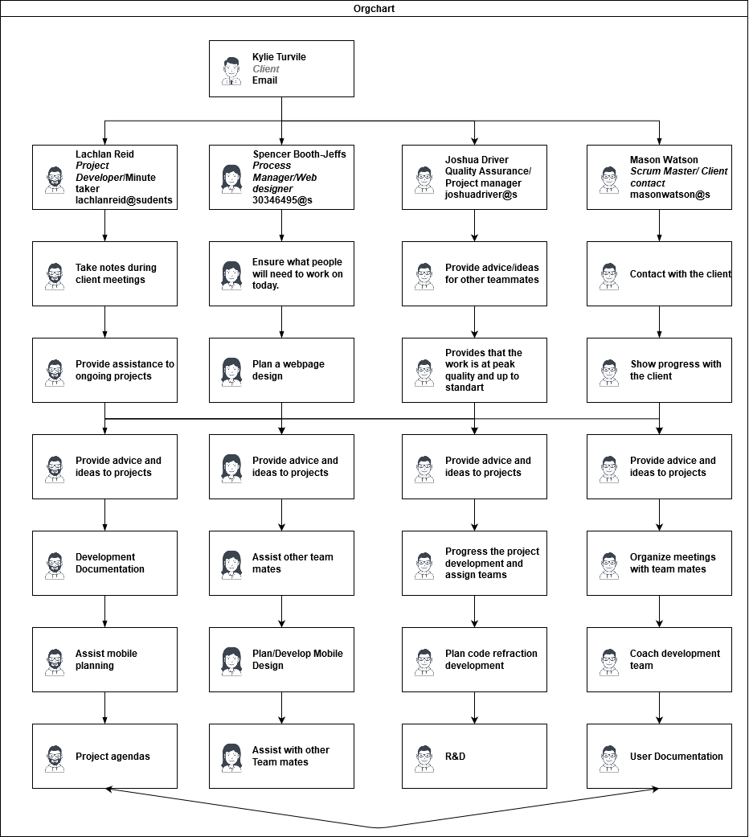

## 2.3 Organization Boundaries and Interfaces

1. ***Communication and Social***

1.1 Because of Covid-19 we cannot meet with our client face to face.

1.2 Client can only be contacted during business hours.

1.3 Meetings must work around her schedule.

1.4 All team members have jobs and other commitments

1. ***Data sets***

2.1 Most of the coding for the data is all over the place, making it hard to interpret

2.2 Some data sets are in 7 different php files, which means it might take a bit longer to be able to get the code on time

1. ***Security and Privacy***

3.1 Some of the data has information that cannot be released to the public or the development team. (Which is being worked on by another development team)

We will use a Microsoft teams chat to plan meeting and use the meet now function to hold meetings, our meetings are usually held once a fortnight and the day and time depend on client availability, Before client meetings we have a team meeting to plan what we will discuss in the meeting, after the client meeting we come together to reflect.

## 2.4 Project Responsibilities

Joshua – Lead Programmer, Testing, Development R&D – Joshua will be our advisor for our projects and a feedback provider to see how well we are doing from an in-depth working point of view since he is one of our team mates, Joshua is also a developer for our primary objective which is the code refraction.

Spencer – Quality Assurance, Testing, Artwork, Process Management – Spencer is responsible for ensuring that each team member is working on their corelated task and to provide support in any way they can help.

Lachlan – Programmer, Testing, Development R&D, Minute taker – Lachlan is one of the developers in the team, his responsibility is to work on our main objectives (Code refactoring) and other objectives if our main objective is ahead in schedule.

Mason – User Documentation, Technical Documentation, Scrum Master, Testing – Mason is responsible for the Documentation, communication with the client and our main person of the Scrum master who is responsible of keeping in check with the scrum.

# Managerial Process

## 3.1 Management Objectives and Priorities

Our management philosophy depends upon the goals of the current sprint. When we are not actively working on a sprint, we value high flexibility it allows us the greatest ability to adapt to changes from the client and allow us to most easily and effectively plan how the next sprint should be carried out, and what our management philosophy should be during the duration of that sprint. Overall, we also aim to maintain high equity during the duration of the project as we are mostly all on equal terms in regard to skills and as such avoiding having a leader will allow us a greater degree of freedom.

The management philosophy we will employ for the duration of the first sprint is one that prioritises that of learning new skills. This is because most of are unfamiliar both with sprint methodology as well as with the skills needed to carry out and progress through the project.

If any interpersonal problems are to arise during the duration of the project we will assemble as a team and discuss these problems. Hopefully the problems can be solved during these discussions, but if that is not possible, we will continue to hold regular meetings until the problems are all sorted out.

We believe that there are no such things as a stupid question and that we encourage creativity, prosperity and inspiration as it is the key to success.

## 3.2 Assumptions, Dependencies, and Constraints

**Assumptions**

* That the codebase to fdlMarks will be provided by the client
* That the pre-existing codebase for fdlMarks will allow for the implementation of a mobile website

**Dependencies**

* The virtual machine with associated data and code provided by the client

**Constraints**

* Not being able to meet face to face and our reliance on online communication.
* The fact that the client has not yet made the backend of fdlMarks available to us.
* The client having a constrained timetable due to current events.
* The inability to access the backend html for the fdlMarks page resulting in us using the html downloaded from the page.
* Mason has work in the mornings.

# Technical Process

## 4.1 Methods, Tools, and Techniques

**PHP** – The PHP application is a type of server that allows you to view and manage Databases using the XML language which is used as a search engine and a rule implementation service.

**VMware** – VMware is an Open Source free application that allows you to emulate another desktop with a different OS, this will mostly be used for the REDHAT OS and the php software.

**Visual Basic** – This is a application that will allow us to interact with the Java Scripts for the webpage and the implementation of the data base into a webpage.

**Red Hat** – Red Hat is an OS server that allow us to interact with the database itself, it also allows you to edit the database and turn it into something else within that large data warehouse

**Microsoft Teams** – Application to use to communicate with client and team and is a work repository that allows you to share your work with authorised teammates, it also allows you to provide meeting amongst your teammates.

**GitHub** – GitHub is a site that allows you to document any issues that might occur within the project, this allows you to provide a community service, so it allows you to get a wide range of techniques and feedback from the general audience/Users, we mostly use this software to manage what we are doing and to specify what problems we have come across, we have also used it to help out with our backlog.

**Notepad ++ / Subline Text** – This is a text editing software that can be used to edit both HTML files (which is the type of file used to place objects on a webpage) and a CSS file which allows you to design your HTML file webpage.

**JavaScript** – A type of software that we will be using to implement the database into the html file, we will also be using it to change the tables behaviour as well so that the table will act a bit more efficient.

**WinSCP** – An application that will allow users to access the servers and files and allows you to upload changes to the HTML and Database.

**Firefox** – It is a web browser software used to determine the look of the webpage.

**Draw.io** - It is a visual diagram maker that provides a distinct idea of how a certain process work and how they correlate with each other.

## 4.2 Software Documentation

We will be making our project compliant with the final fed 002 brand guidelines. Examples of this are the list of fonts sizes and colours we can use in this product. Because this is not a new product and just making an existing product better, we will not need to give a lot of instructions to users as it is very self-explanatory, we will how ever have documentation of how we have approved the product. examples of this is we will be making the website quicker and more user friendly for the mobile environment.

# High level Project Plan

**Sprint 1 Goal** - The goal of sprint 1 is to have a high-level prototype of the interface as well as improve knowledge on PHP, the key objectives are Achieve a quality prototype and gain knowledge on PHP. This will be indicated done when the client approves of the product.

* + Design webpage (Site map, Wireframe, Mock-up)
  + Design webpage (Phone) (Wireframe, Mock-up)
  + Code Homepage design with a responsive design
  + Create JavaScript for phone compatibility
  + Learn php
  + Analyse code provided by client.

**Sprint 2 Goal** - The goal of this sprint is to have a significant portion of the code refractor finished and to have a more user-friendly interface. Key objectives, Progress on the code refractor and have a user-friendly interface This will be evaluated by the number of functions left without comments and the user speed of fdlMarks and it will need to be approved of by the client. Sprint 2 will also provide a couple of penetration testing involving the application mega exploit which is a device that will allow you to determine the safety of fdlMarks, if the penetration testings ceases to successfully obtain information that was not intentionally accessed through permissions, we will seek to resolve this problem through negotiation with our client in hopes of providing feedback, so that the security can later be improved.

* + Refine JavaScript code compatibility
  + Comment functionality for coding
  + Refactor coding for php
  + Penetration testing analysis.

**Sprint 3 Goal**- Labelled all functionalities and streamlined fdlMarks removing redundancies This will be evaluated by the number of functions left without comments and the user speed of fdlMarks, provided by all the penetration testings provided by mega exploit, we will be able to take action on the vulnerabilities that haven’t been developed on.

* + Finish main page design
  + Code refractor all main fdlGrades core.
  + Add security modules.

**Sprint 4 Goal** - Hand over a product that meets the client's expectations and prepare a presentation the key objective is to hand over a high-quality project and then present It alongside the other projects. It will be evaluated base on client feedback.

* + Simulation testing
  + Real user testing
  + Client feedback
  + Product presentation.

## **Phases**

Project planning -> Analysis -> Design -> Development/Acquisition -> pilot test -> Revision and Demonstrate

Our 3 main things we value and are taking maintained control over are:

* Quality
* Performance
* Schedule

Figure – Sprint Plan

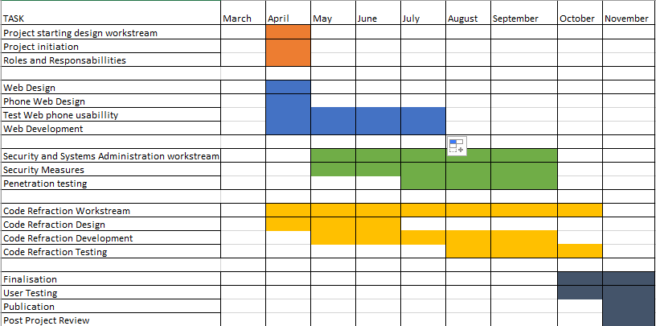

GitHub repository: <https://github.com/ITECH3208andITECH3209feduni/capstone-projects-2020-project-131/projects/2>

# Non-functional Requirements

## 6.1 Platform

The fdlMarks website must be tailored to be more usable on android devices. This is one of the main goals of the project and will be successful if students are able to comfortably use   
fdlMarks on their mobile devices.

## 6.2 Communication

FdlMarks will need to be able to successfully work and integrate into the fdlGrades system. This is moderately important as it is one of the deciding factors as to whether the client will use the product as is, however, it isn’t the main goal that the project hopes to satisfy. It will be successful if the system is able to seamlessly integrate with fdlGrades.

## 6.3 Performance

The database will need to be optimised so that it functions more efficiently on the universities servers. Another aspect of performance will be improving how fast the fdlMarks site loads. Both are of low importance as the project doesn’t directly aim to improve performance but by refactoring the code of the existing system performance should hopefully improve regardless. This will be a success as long as any sort of performance increase is achieved in either case.

## 6.4 Security and Privacy

University student’s grades will need to be secure so that they are unable to view other student’s grades and unauthorised people are not able to view their grades. This is of very high importance to the system as any leakage of information could be catastrophic. This will be successful if the security put in place is able to protect the information of university students. During demonstrations we will not show any student personal data of non-team members including names or grades etc.

## 6.5 Audience, Usability and Accessibility

University students need to be able to use fdlMarks on their mobile phones to comfortably look at their results and their study plan. This is of high importance and ties in with the platform, with the measurement of success being the same. International students will need to be able to read and understand their grades and study plan on fdlMarks. This is of low importance and is an extra goal for the project to meet but lies outside of its main goals. It will be successful if any sort of other language is implemented.

## 6.6 Reliability

Students will need to be able to trust fdlMarks to reliably present them with their grades. This is of high importance as miss reporting of grades to a student could either lead to unnecessary anxiety or if grades are shown higher than they are unnecessary confidence. This will be a success if the database correctly supplies students with the correct information.

## 6.9 Legal

The system will need to adhere to privacy and security laws regarding student’s information. This is of moderate importance as while we will try to improve upon the security of the system, the final implementation of the system is ultimately up to the client, and while we are working on the system this doesn’t apply us much to the project.

## 6.10 Standards

The system will need to adhere to the standards set by the pre-existing database and the pre-existing system. This is of high importance as if we don’t follow these standards the system, we change might end up becoming incompatible with the existing system. This will be a success if all standards are followed. We will also need to be Complient with the FedUni brand guidelines.

## 6.11 Documentation

The back-end code for fdlMarks will need to be modified such that is both more readable and that it is also documented better. This is of high importance as this is another one of the projects main goals. It will be successful if all the back end is refactored with appropriate comments in the code and further documentation with explanations on how the system functions.

# Software and Systems Architecture

## 7.1 Architecture objectives

At this current point we can’t say exactly how the underlying architecture of fdlMarks looks as we do not have access to it, but we understand as whole though how it is going to look in the end. The fdlMarks site will be a frontend for students to access information stored about themselves located in the fdlMarks database, and the backend of fdlMarks will integrate with fdlGrades which is the system used by lecturers to manage the information that is relevant to them and their students.

Figure – Architecture Design

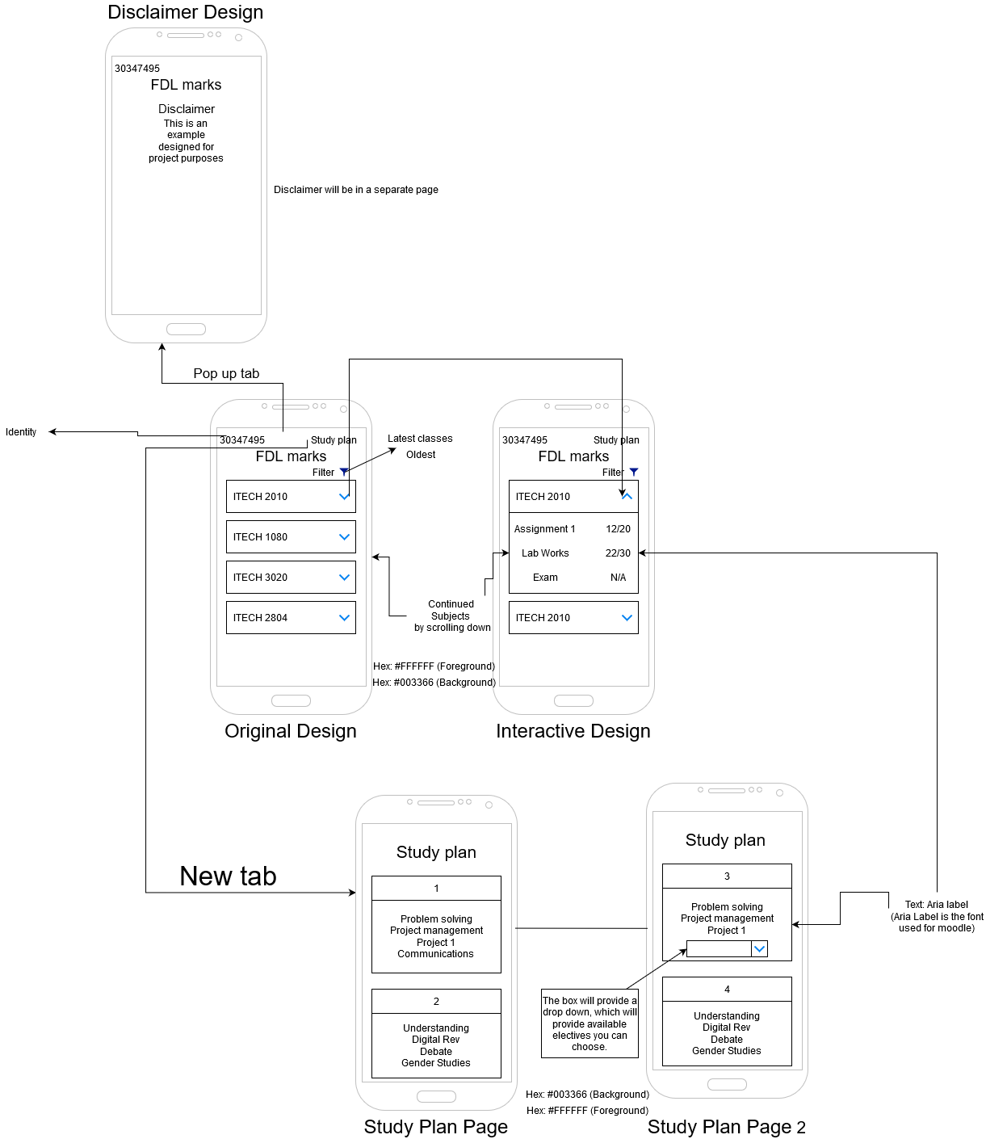

## 7.2 High-level architecture

The type of architecture design that will likely be present in the final implementation will be some of n-Tier architecture. As previously stated, the design of the architecture is dependent on how the current form of fdlMarks was designed, we not really be able to have any significant design on this architecture, and as we currently do not have access to it we can’t be sure of what the current architecture actually looks like, besides the things we can gleam by looking at the site and the things told to us by the client.

Provides a visual design how each application interacts with one another,

Figure - Architecture Overview

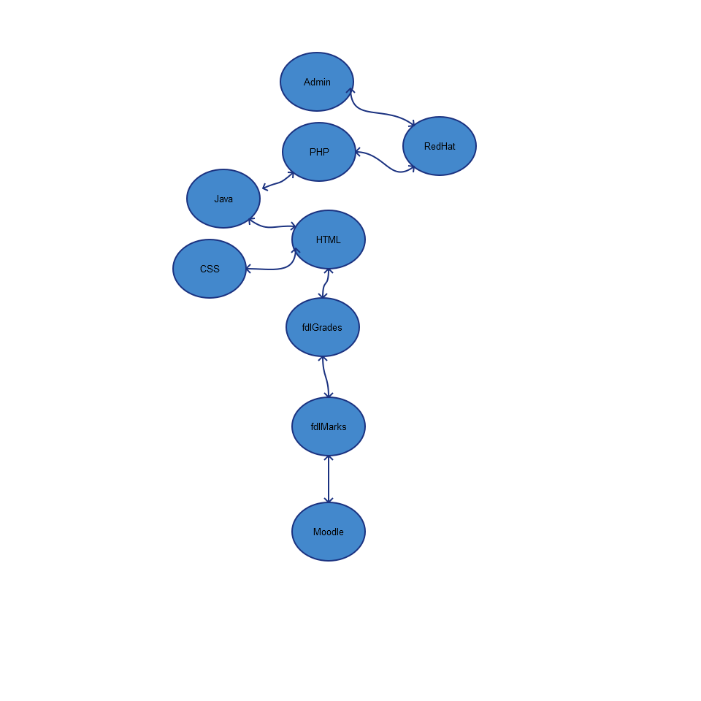

## 7.3 System context

The fdlMarks site that we will be working on pulls information from the fdlMarks database, and the fdlMarks system sits underneath of the fdlGrades system. The fdlMarks site interacts with the fdlMarks database so that it can show students the relevant information about themselves, such as their grades for various assignments. The fdlMarks system interacts with the fdlGrades system so that it can populate the fdlGrades database with relevant information, as fdlGrades is the system through which university staff members manage the courses they are in charge of as well as the students enrolled in those courses.

Figure - System Context

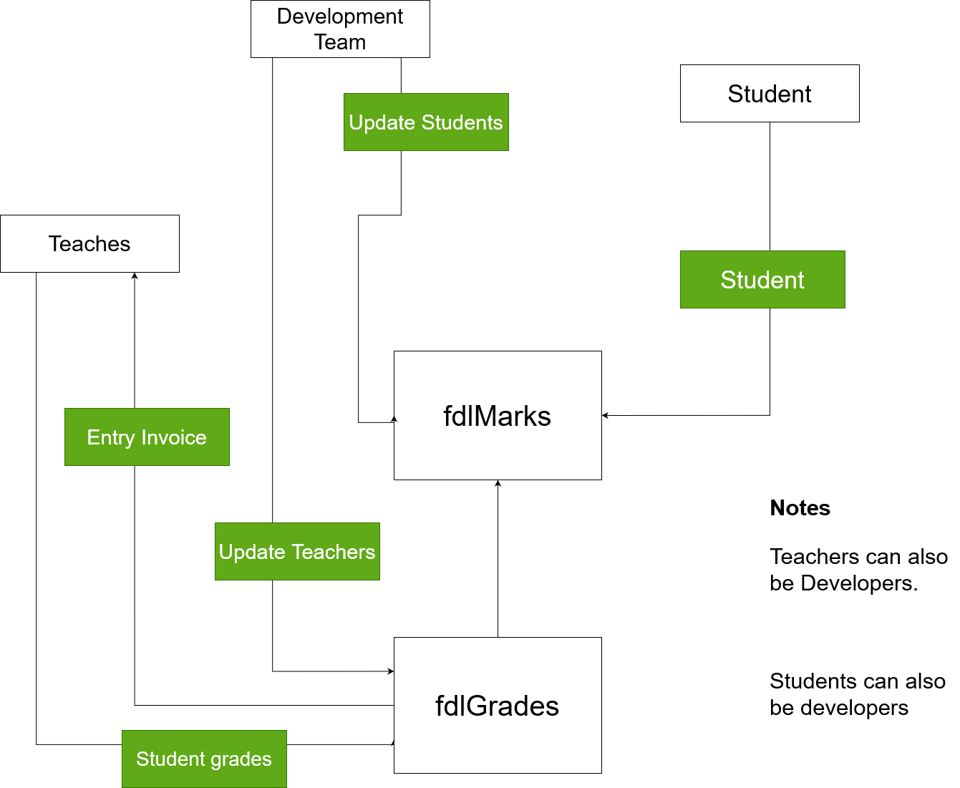

7.4 User Interface / Interaction Design

The general idea behind all of the user interface designs is to make them so that they are flexible and will work on a large variety of different mobile devices despite the differences in the various screen sizes of these mobile devices.

Wire frame to show us how each function works and how the site will look and where each object will be placed upon.

Figure - User Interface Design

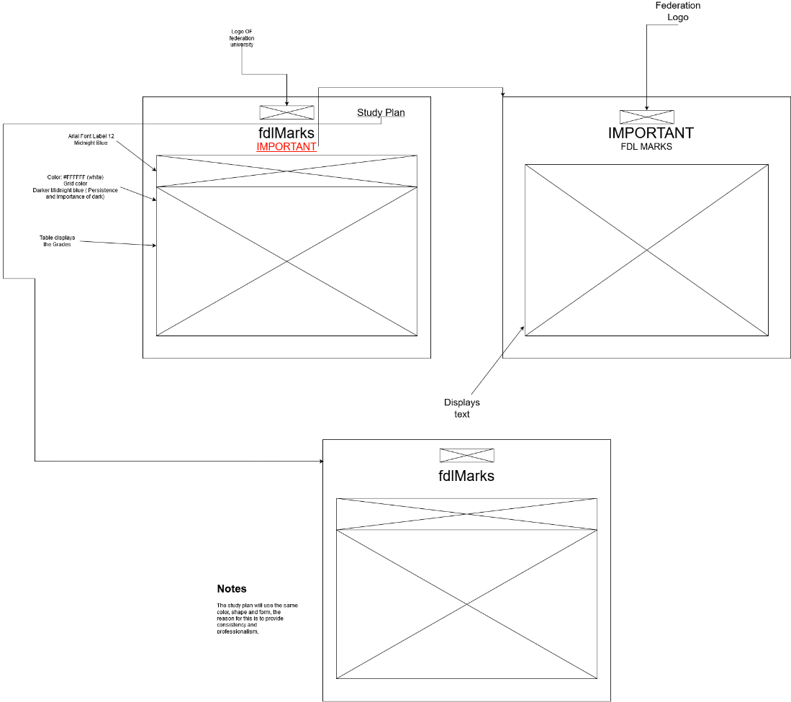

This is the site map, this shows how the webpage works, and how you get from one page to another.

Figure - Sitemap

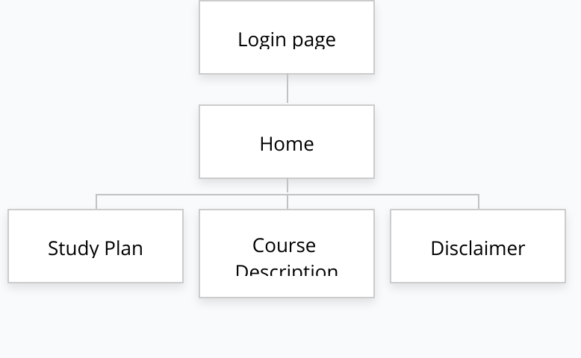

A mock-up design that will help give us what we went for our design.

Figure - Design Mock-up

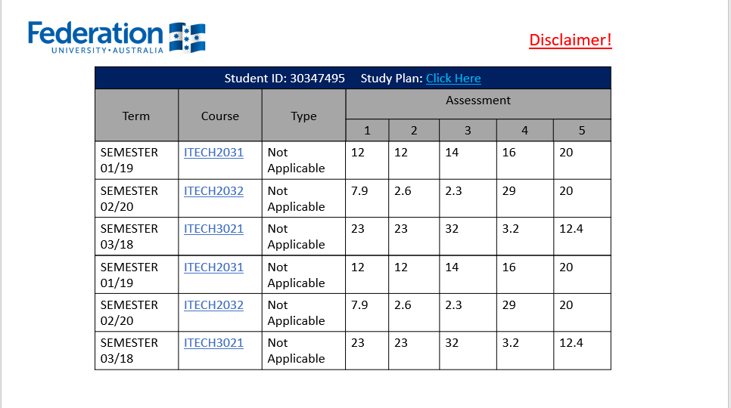

## 7.5 Data model and software design

Based on what we know this is what the very bare minimum of what the database should look like, if what the client said about the database is to be believed there should be many more tables than the ones seen in the diagram below, but at this current point in time we are not exactly show what those tables are or how the interact with the database. The diagram below is simple by design as it makes sure we don’t make too many assumptions about what the database looks like and keeps our minds open when we do eventually receive it.

Figure - Database Design

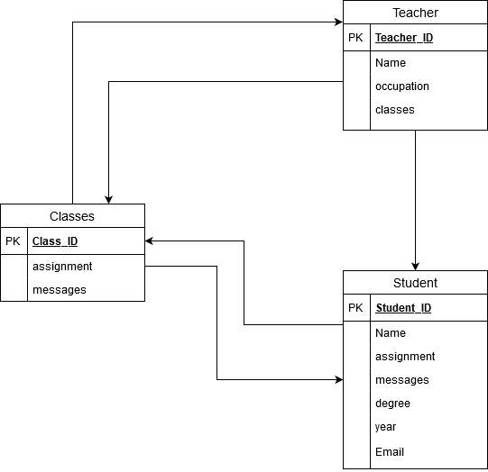

## 7.6 Assumptions

* fdlMarks pulls the data from fdlGrades
* Students will only use the site for small durations of time
* Students check the site at least once a week
* Students have easier access to a phone then a laptop or desktop device
* FdlMarks creates the site through a variety of PHP commands

## 7.7 External Dependencies

* The fdlGrades system
* The host for the website
* VMware server

# Additional Components

* We have been using multiple PHP training tutorials to help us understand the functionally.
* Used YouTube to provide suggestions for software management.

Privacy Act 1988

The objects of this Act are:

(a) to promote the protection of the privacy of individuals; and

(b) to recognise that the protection of the privacy of individuals is balanced with the interests of entities in carrying out their functions or activities; and

(c) to provide the basis for nationally consistent regulation of privacy and the handling of personal information; and

(d) to promote responsible and transparent handling of personal information by entities; and

(e) to facilitate an efficient credit reporting system while ensuring that the privacy of individuals is respected; and

(f) to facilitate the free flow of information across national borders while ensuring that the privacy of individuals is respected; and

(g) to provide a means for individuals to complain about an alleged interference with their privacy; and

(h) to implement Australia’s international obligation in relation to privacy.